**INDIVIDUAL HCI LAB PROJECT**

(Shafalda Bilqis Sceishar – 2602186775)

**ASSETS LINK REFERENCES**

* color palette inspo ([https://www.color-hex.com/color-palette/53679)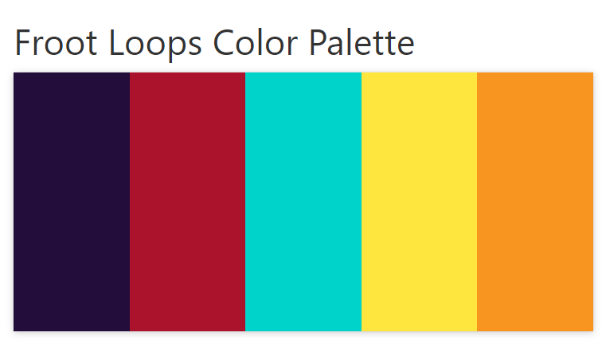](https://www.color-hex.com/color-palette/53679))
* logo: Amaranth (font)



* <https://www.pngguru.in/image/call-icon-free-transparent-png>



* <https://www.vecteezy.com/photo/11833469-bowl-of-colorful-children-s-cereal-and-milk-isolated-on-wood-table-with-text-space>

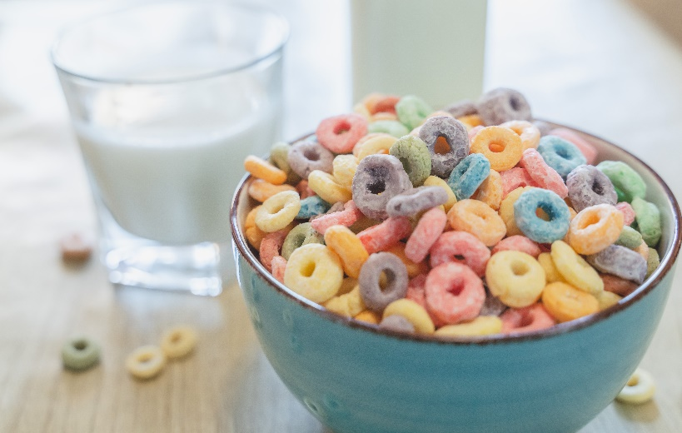

* <https://www.vecteezy.com/photo/25025531-activities-together-during-the-holidays-parents-and-children-are-having-a-meal-together-during-the-holidays-mather-prepare-milk-for-son-on-morning-enjoy-weekend-vacant-family-time-happy>



* <https://www.vecteezy.com/photo/39624288-ai-generated-freshness-and-sweetness-in-a-close-up-of-homemade-dessert-generated-by-ai>

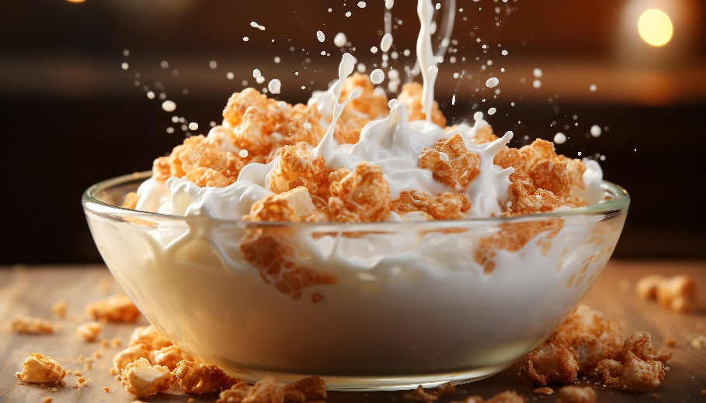

* <https://www.kelloggs.co.uk/en_GB/brands/kellogg-s-corn-flakes-.html> (adult product 1)

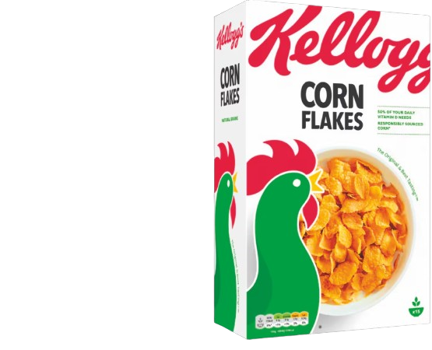

* <https://www.kelloggs.co.uk/en_GB/products/fruit-n-fibre.html> (adult product 2)

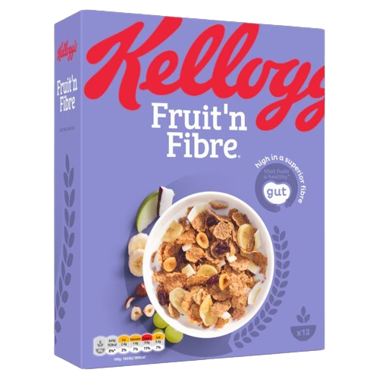

* <https://www.kelloggs.co.uk/en_GB/products/bran-flakes.html> (adult product 3)

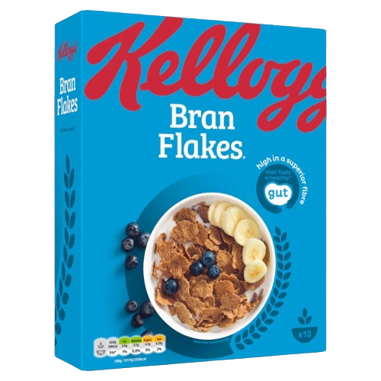

* <https://www.kelloggs.co.uk/en_GB/brands/coco-pops-.html> (kids product 1)

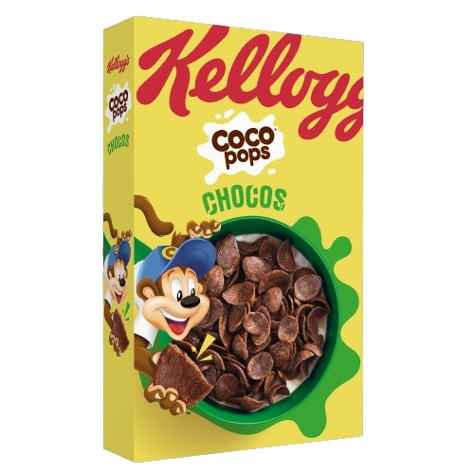

* <https://www.kelloggs.co.uk/en_GB/products/frosties-cereal-milk-bar.html> (kids product 2)

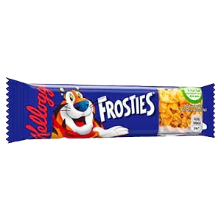

* <https://www.kelloggs.co.uk/en_GB/products/pop-tart-strawberry-sensation.html> (adult product 4)

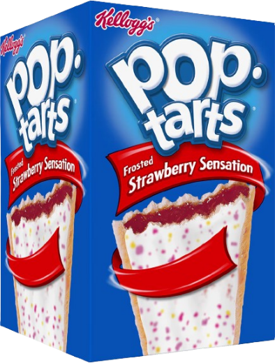

* <https://www.kelloggs.co.uk/en_GB/brands/rice-krispies-squares-.html> (kids product 3)

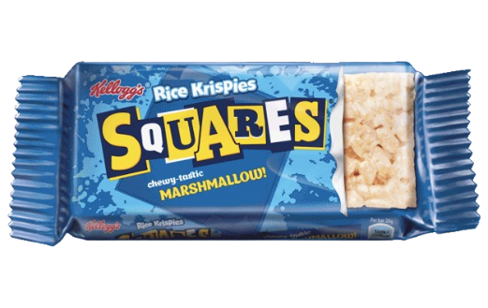

* <https://www.kelloggs.co.uk/en_GB/products/krave-stix-milk-chocolate.html> (kids product 4)

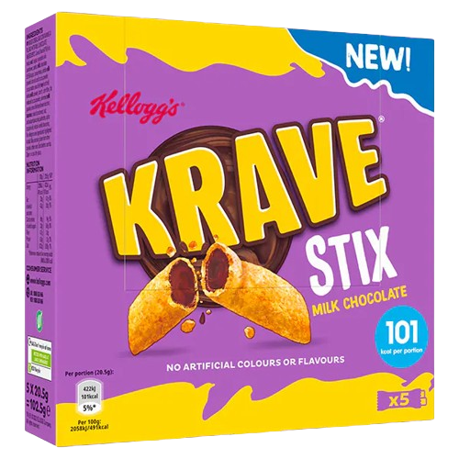

* <https://www.kelloggs.co.uk/en_GB/products/coco-pops-cereal-milk-bar.html> (kids product 5)

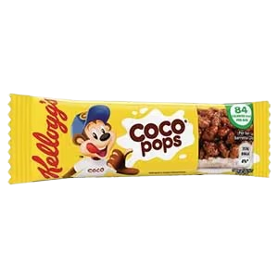

* <https://www.kelloggs.co.uk/en_GB/products/fruit-loops.html> (kids product 6)

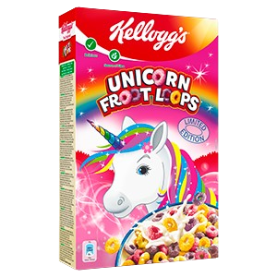

* <https://www.kelloggs.co.uk/en_GB/products/hs-kell_nuttychewybar-rstalmdchocchunk.html> (adult product 5)

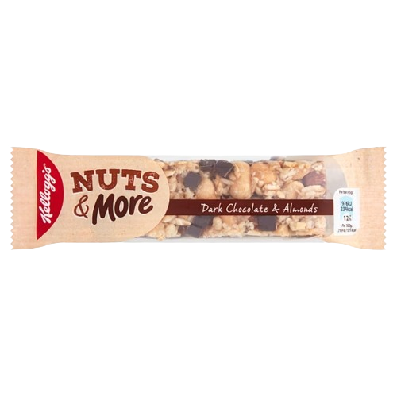

* <https://www.kelloggs.co.uk/en_GB/products/kellogg-s-nutri-grain-cereal-bars-manzana-apple-limited-edition-product.html> (adult product 6)

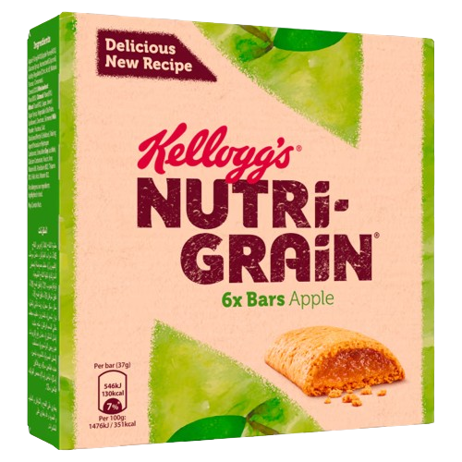

* <https://www.kelloggs.co.uk/en_GB/recipes.html>

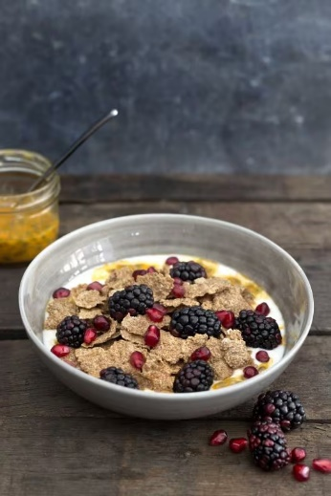

* Recipe 1: <https://www.kelloggs.co.uk/en_GB/recipes/a-winter-s-tale-recipe-recipe.html>
* <https://www.strawberryblondiekitchen.com/cherry-mash-truffles/>

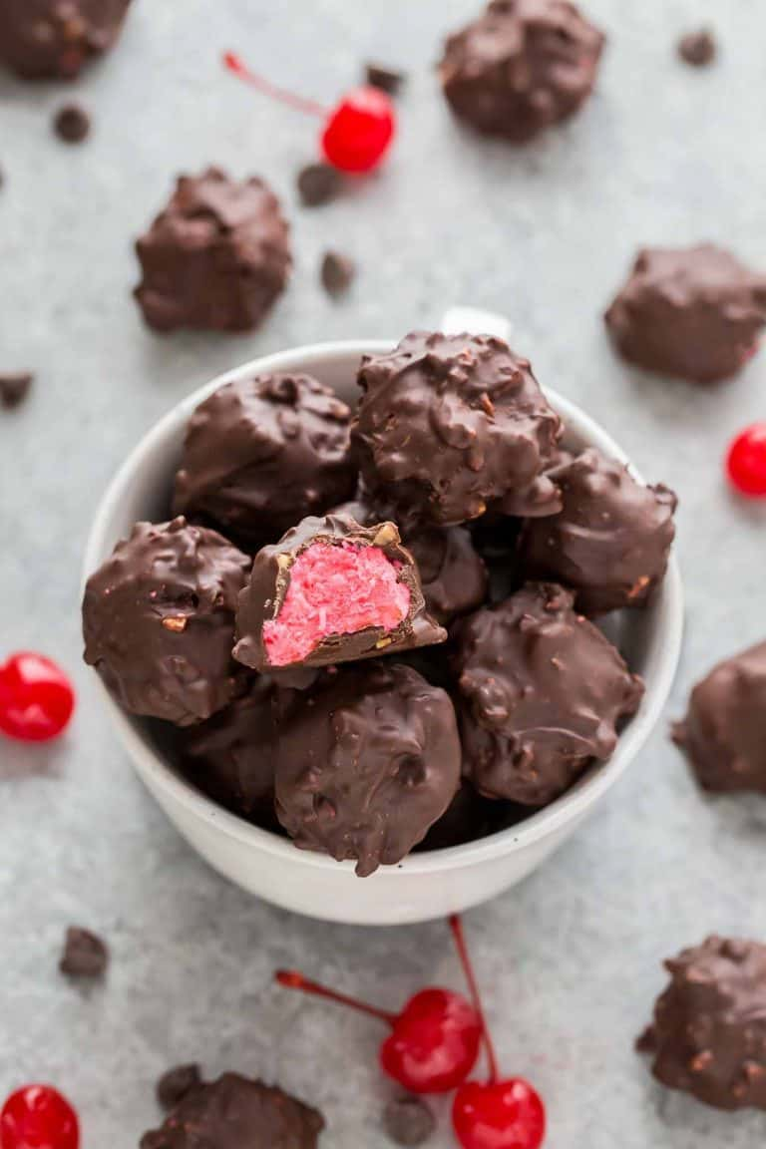

* Recipe 2: <https://www.kelloggs.co.uk/en_GB/recipes/cherry-chocolate-treats.html>
* <https://www.kelloggs.co.uk/en_GB/recipes.html>

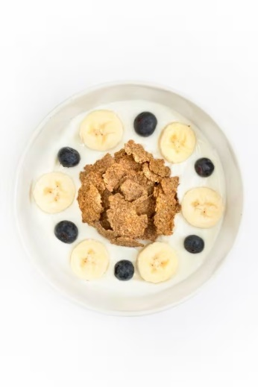

* Recipe 3: <https://www.kelloggs.co.uk/en_GB/recipes/blueberry-banana-bran-bowl-recipe.html>
* <https://www.kelloggs.co.uk/en_GB/recipes.html>

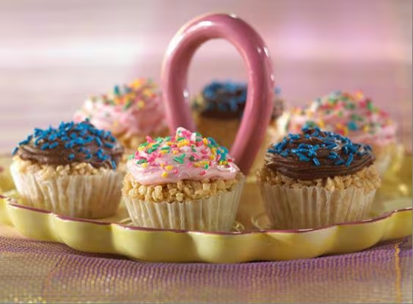

* Recipe 4: <https://www.kelloggs.co.uk/en_GB/recipes/crunch-a-bunch-cupcakes.html>
* <https://www.kelloggs.co.uk/en_GB/recipes.html>

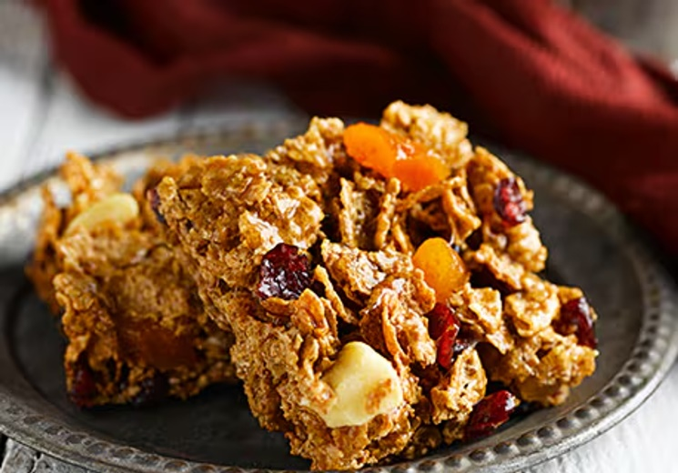

* Recipe 5: <https://www.kelloggs.co.uk/en_GB/recipes/dried-fruit-cereal-bars.html>
* <https://www.kelloggs.co.uk/en_GB/recipes.html>

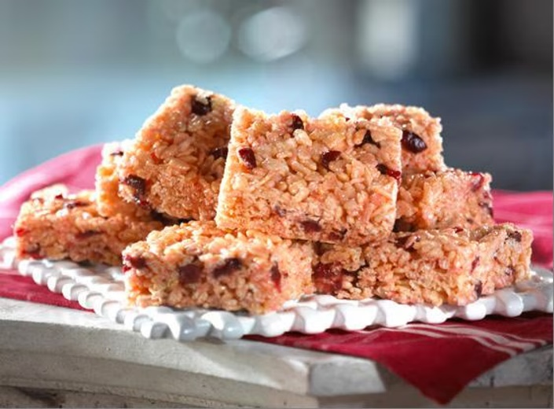

* recipe 6: <https://www.kelloggs.co.uk/en_GB/recipes/very-cherry-treats.html>
* <https://blog.shorts.uk.com/what-is-a-group-company-structure>



* <https://www.pxfuel.com/en/desktop-wallpaper-uxonp>

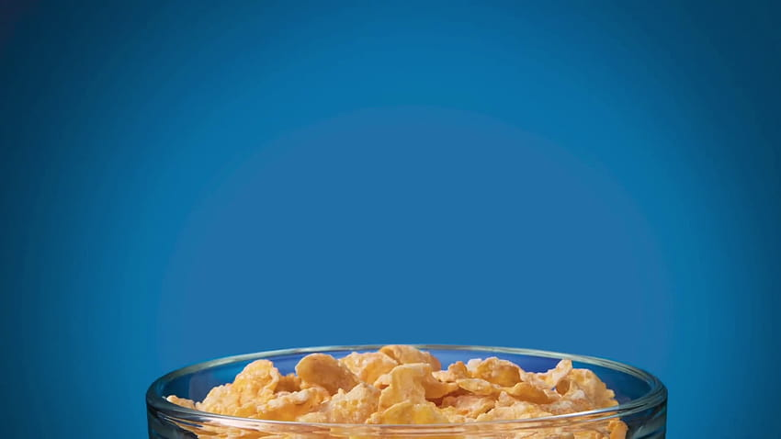

* <https://www.pngall.com/checklist-png/>

